

The Brewing Bar Checkout and Stock System

In Partial fulfillment of the requirements in IT12/L
System Integration and Architecture

Presented By:

Enola, Dionne Emmanuel M.
Yute, Christina Paula P.
Zaragoza, Liz T.

IT 12/L - 3441

Presented To:

CHARISSE P. BARBOSA
Instructor

September, 2026

TABLE OF CONTENTS

Chapter 1: The Company
Company Profile | 4
Organizational Chart | 4
Business Environment | 6
Description of the Existing System | 6
Data Flow Diagram | 7
Chapter 2: The Problem
Statement of the Problem | 8
Feasibility Study | 9
Chapter 3: The Solution
Methodology | 10
System Objectives | 11
System Requirements | 12
Database Relationship Diagram | 14
Use Case Diagram | 14
Scopes and Limitations | 15
Security Plan | 18
Implementation Plan | 19
System Evaluation | 20
System Prototypes | 29

LIST OF TABLES

Table 1: … | 11
Table 2: … | 12
Table 3: … | 13
Table 4: … | 21
Table 5: … | 22
Table 6: … | 23
Table 7: … | 24
… | —
Table n: … | —

LIST OF FIGURES

Figure 1: … | 5
Figure 2: … | 7
Figure 3: … | 10
Figure 4: … | 14
Figure 5: … | 14
Figure 6: … | 19
… | (insert number here)
Figure n: … | (insert number here)

Chapter 1

THE COMPANY

Company Profile

The Brewing Bar is a food, beverage, and hospitality training enterprise located at Gravahan, New Matina, 74-A Purok 2 Rd, Davao City. Established on February 10, 2023, General manager, John Lloyd Dagatan, the business operates within the local restaurant, cafe, and vocational education sector. It caters primarily to students, local residents, and coffee enthusiasts by combining an accessible dining space with specialized beverage consultancy and short-term skills development programs. In its daily operations, the enterprise functions as a commercial cafe handling dine-in and takeout transactions, while concurrently hosting scheduled training workshops such as basic barista and bread & pastry courses. Managing approximately 60 to 70 transactions on standard weekdays and scaling to over 100 customer interactions during weekends and peak periods, the business maintains a steady presence in the Matina community.
The manager interview recorded the company’s stated mission as continually improving operations and customer care while providing high-quality, affordable food and beverages, especially for students. The stated vision is to be a cozy, affordable place for customers, particularly students, to spend time. No separately approved list of formal corporate objectives was supplied; the operational priorities described in the interview are affordable service, customer care, and reliable daily café operations.
Products and Services. The business serves coffee, non-coffee drinks, juices, prepared meals, pastries, and baked goods. It also offers short vocational workshops, including basic barista and bread-and-pastry training. This project covers the café’s point-of-sale, kitchen, inventory, purchasing, and finance workflows; workshop enrollment and venue reservations remain outside the current system.
Current technology: The interview notes that the business has a laptop, a tablet, and Converge internet service. It has no working receipt printer or computerized checkout and record system. The project contains website files. The supplied materials do not show that the website is installed at the café or ready for daily use.

Organizational Chart

The Brewing Bar operates under a centralized, family-supported micro-enterprise organizational structure, consisting of two primary on-site operational roles supported by ownership oversight:

- General Manager (John Lloyd Dagatan): Holds strategic, financial, and administrative authority. The manager oversees procurement, supplier coordination, training batch scheduling, financial accounting, and day-to-day cashiering and counter customer service.

- Cook / Bar & Kitchen Staff: Responsible for beverage preparation, baking, food live business use, kitchen waste tracking, and physical stock checks. The cook directly coordinates with the front counter regarding order tickets and raw material availability.

- Family Support Personnel: Assist intermittently with operational monitoring, counter supervision, and shop upkeep during peak service volumes.

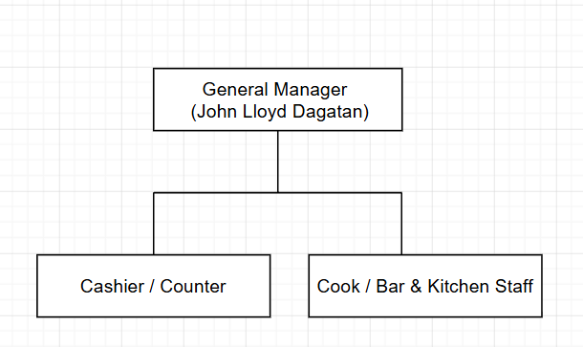

Figure 1: Organizational Chart

Business Environment

The business environment of The Brewing Bar encompasses both internal operation conditions and external market factors shaping its daily operations.

- Target Market & Customer Demographics: The business primarily serves students, young professionals, neighborhood residents, and coffee enthusiasts within the Matina and greater Davao City area. Because of its proximity to academic institutions and residential communities, patron demand centers heavily around affordability, comfortable study spaces, and student-budget pricing.

Description of the Existing System

The Brewing Bar currently handles most sales and stock records by hand, using paper and personal devices. It does not have a dedicated computerized checkout and record system.

- Order Entry and Billing Subsystem

At the counter, the cashier or manager writes each sale in a paper notebook and prepares handwritten slips. They record the item, quantity, size, flavor, dine-in or takeout choice, and any special request.

- Inventory and Stock-Tracking Mechanism

The business operates without real-time or automated inventory tracking, meaning raw materials and ingredients are not decremented dynamically when sales occur at the counter. Supplies such as coffee beans, dairy cartons, flavored syrups, and baking flour are ordered from commercial vendors every three weeks to a month based on visual inspections of remaining stock. When deliveries arrive, items are manually verified against supplier delivery receipts for item name, quantity, unit type, date received, cost, and physical condition before being entered into a dedicated supplier notebook. In-house pastry live business use is managed by the manager’s mother, who standardizes whole cakes into exactly ten slices per unit for individual retail sale. Spoilage and ingredient damage—such as unchilled dairy or accidental kitchen spills—are logged separately as operational expenses on the day they occur rather than being dynamically adjusted in a stock ledger. Meanwhile, meals consumed by staff or family members are treated as regular customer orders and recorded manually to mitigate stock variance. Raw ingredient deductions are calculated only at the end of the day based on cup sizes (small, medium, large) and recorded recipes, after which the cook audits the kitchen stock while the manager audits the bar inventory during a manual closing process that takes one to two hours.

- Order Routing and Kitchen Communication

The operational interface between the cashier counter and the preparation area relies entirely on verbal word-of-mouth communication alongside physical notes. When a customer order is logged, the cashier verbally informs the cook/barista or hands over written notes. When food or beverage preparation is finished, the cook communicates back to the cashier through word of mouth to signal that the order is ready for customer pickup. This reliance on verbal queuing causes transition lags of 2 to 3 minutes during peak hours. If a beverage or pastry ingredient is depleted mid-preparation, live business use halts while the cook verbally alerts the cashier, forcing counter staff to negotiate alternative menu selections with the customer.

- Reporting and Data Storage

Daily gross revenue, custom order payments, and stock audit tallies are manually recorded inside paper logbooks. The manager reconciles daily cash by matching physical drawer cash against written order totals, and cross-checks recorded GCash 4-digit reference numbers against digital wallet logs. Formal business reports—such as daily sales, weekly sales, best-selling drinks, and training workshop fees—are not stored in digital spreadsheets or databases. They exist strictly across handwritten notebook pages, requiring management to spend 10 to 15 minutes manually flipping through historical pages to identify weekly bestsellers or draft supplier replenishment orders. Formal Purchase Orders (P.O.) are not generated automatically, making it difficult to project accurate stock replenishment schedules or maintain long-term financial records.

Data Flow Diagram

Figure 2a. System Context Diagram

Figure 2b. Level-0 Data Flow Diagram
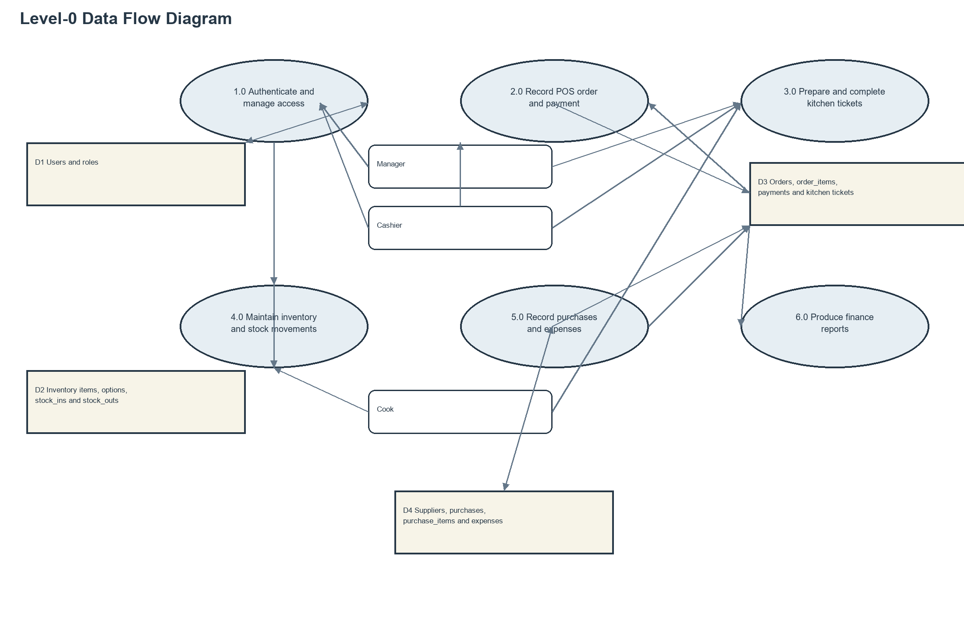
Figure 2a shows the manager, cashier, and cook using the website. Figure 2b shows its main parts: staff sign-in, orders and payments, kitchen tickets, stock records, purchases and expenses, and finance reports. Suppliers do not use the website; staff enter supplier and purchase details.
Chapter 2

THE PROBLEM

Statement of the Problem

During the September 5, 2026 interview, The Brewing Bar used paper notebooks and verbal communication instead of one shared checkout and stock system. The interview notes report about 60 to 70 customer sales on a typical day and more than 100 during busy periods. Staff described a 2 to 3 minute delay when an order had to be changed.

Slow Order Flow and Delayed Kitchen Communication
Using paper notebooks to write down orders slows down service on busy days when total daily orders go over 100. For instance, when many students arrive at once, the cashier writes down order quantities, cup sizes, flavors, and special requests in a notebook while working out total prices and 20% discounts by hand. If a customer changes an order, the cashier uses white tape or crosses out lines in the notebook and calls out the changes to the kitchen. This creates a 2 to 3 minute delay between the counter and the kitchen, makes customers wait longer in line, and causes order mix ups.

No Computerized Checkout or Payment System
The business has tablets, laptops, and internet on site, but lacks an automated store system, a connected cash drawer, or a receipt printer. For example, when a customer pays using GCash, the cashier must pause the order taking to look at the payment picture on the customer phone or copy down the reference number into the paper notebook by hand. This slows down the line and opens the business to fake or unverified payments.

Manual Inventory and Purchase Order Tracking
Tracking stock on paper forces staff to count physical items by hand at the end of the day. Ingredients bought in bulk like kilograms of coffee, cartons of milk, bottles of syrup, or whole cakes are used per cup or plate, but the paper notebook does not subtract these items as they are sold. This causes items like bread or signature drinks to run out unexpectedly during the middle of the shift. Because there are no real time low stock alerts or automatic supply order forms, the manager cannot alert suppliers in time before long delivery wait times cause prolonged stockouts.

Can the Project Be Used?

Fit with Daily Work
The proposed system is operationally feasible because it addresses the current business processes and operational concerns of The Brewing Bar. The business currently relies on handwritten notebooks for recording inventory and transactions, making it difficult to monitor stock throughout daily operations. The proposed system can support the responsibilities of the Manager, Cashier, and Cook by providing functions related to inventory, order processing, payments, sales, and order preparation. The business also confirmed its willingness to participate in a system demonstration and usability testing, indicating that the proposed system can be introduced into its existing operations.

Equipment and Setup Needs
The proposed website could be used with the business’s laptops or tablets and internet connection. However, the supplied materials do not show that it has been installed or prepared for the café’s devices and network.

Cost
The proposed system is economically feasible because it may help reduce the time and effort required for manual business operations. The Brewing Bar currently spends approximately 20 to 30 minutes calculating daily sales totals and one to two hours performing inventory checking, depending on business activity. The business also experiences inventory discrepancies caused by manually recorded transactions and unrecorded consumption of items. The estimated monthly loss from waste or spoilage is less than ₱600. By improving inventory monitoring and automating sales and stock calculations, the proposed system may reduce manual work, improve inventory accuracy, and support more efficient use of business resources.

Time Plan
The planned work is manageable when limited to the features present in the project: staff access, order entry, payment records, kitchen progress, stock receipts and removals, supplier and purchase records, expenses, and finance reports. The project does not include saved recipes, automatic ingredient tracking, or automatic purchase requests. The supplied materials also contain no signed schedule or installation record; therefore, the dates discussed here describe the academic plan rather than confirmed installation activities.

Chapter 3

THE SOLUTION

How the Team Worked

The team followed an iterative approach, developing the website in stages and reviewing each stage for possible improvements. The team gathered needs from the September 5, 2026 interview, planned the screens and stored information, and added features for orders, kitchen progress, stock, purchases, staff accounts, and finance reports. A demonstration and user review remain necessary; the supplied materials do not show that they took place. This approach reflects the Agile Manifesto’s emphasis on working software and feedback (Beck et al., 2001).

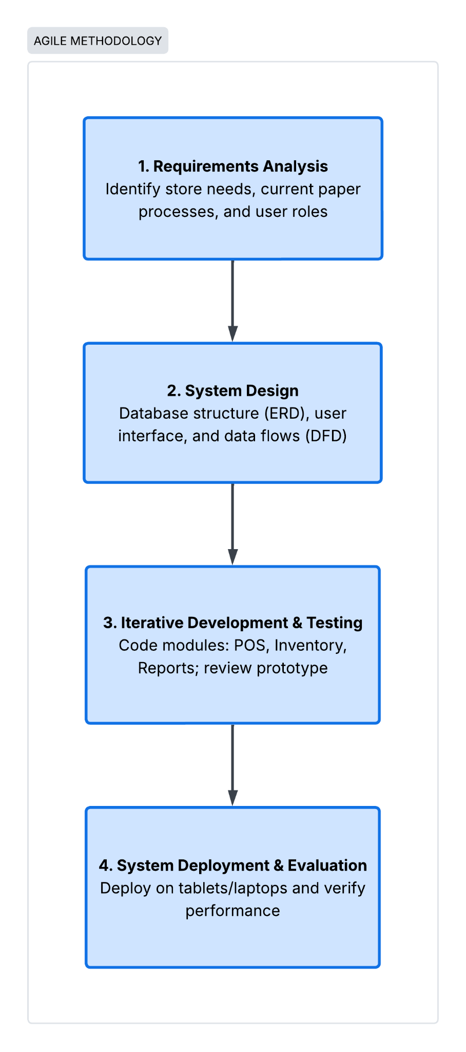

Figure 3: Steps for planning, building, and reviewing the website

Figure 3 presents four stages: identify the café’s needs, plan the screens and stored information, develop the features in stages, and review the results. The project includes screens for checkout, payments, kitchen progress, stock, purchases, and finance reports. The supplied materials do not show that the website was installed at the café or reviewed by its staff. Recipe-based ingredient tracking and automatic low-stock purchasing are not included.

System Objectives
- To let staff record dine-in and takeout orders on a website, including items, quantities, choices, and notes, instead of writing order slips by hand.

- To calculate order subtotals and the configured 20% Senior Citizen or PWD discount, and to record Cash or GCash payments with the GCash reference number entered by staff.

- To record stock receipts and removed stock records and display menu stock status from recorded stock movements.

- To send each ordered item to the kitchen list so staff can mark it Pending, Preparing, or Ready, and then mark the order Completed.

- To let managers review sales and expenses by date and download finance reports as PDF or Excel files.

System Requirements

Hardware Requirements

Table 1. Hardware Requirements
Equipment | Purpose | Notes
Desktop or laptop computer | Runs the website for staff | One computer for setup and testing
Internet or local network | Connects staff to the website | Needed while taking orders
Receipt printer | Prints customer receipts | Only if the café chooses to use one
Backup storage | Keeps a separate copy of saved information | A backup plan still needs to be set up

Table 1 separates devices named in the interview from equipment needed to develop and host the system. A laptop or tablet can open the website. A hosting computer is needed if several staff members are to share the same system, but the supplied project files do not identify a live hosting computer or provider. The system does not connect to a receipt printer, barcode scanner, or cash drawer.

Software Requirements

Table 2. Software Requirements
Program name | What it does | Notes
Windows or another supported computer system | The basic program that runs the computer | Choose one supported by the café
PHP 8.2 or newer | The behind-the-scenes program needed to run this website | May need help to install
Composer | A tool that adds the website’s required parts | Used during setup
Node.js and npm | Tools that prepare the website screens | Used during setup
MySQL | A program that stores orders, staff, and stock information | The final choice must be confirmed
Web browser | The program staff use to open the website | For example, Chrome or Edge
Laravel website files | The supplied website materials | Installation is not confirmed

Table 2 lists the computer programs named in the project. Some are used to run the website, prepare its screens, or store its information. These names are included to help with installation; staff using the website normally only need a web browser. The project’s setup guide mentions MySQL, while a sample setup uses SQLite. The final choice of saved-information program should be confirmed before installation.

Saved Information Relationship Diagram

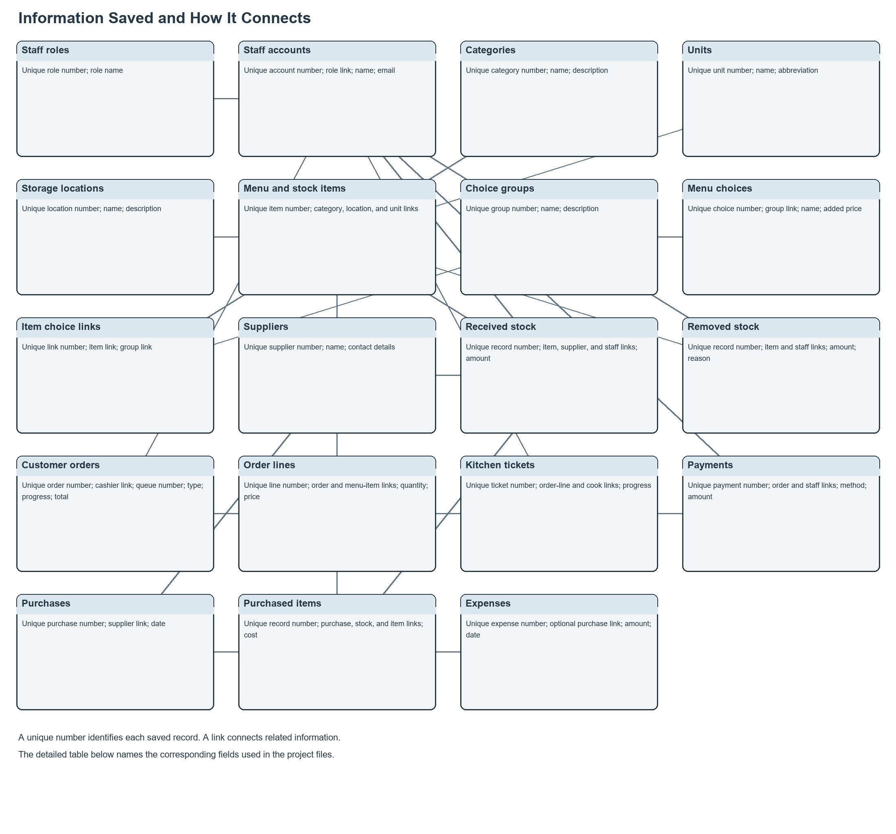

Figure 4: How the website’s saved information is connected
Use Case Diagram

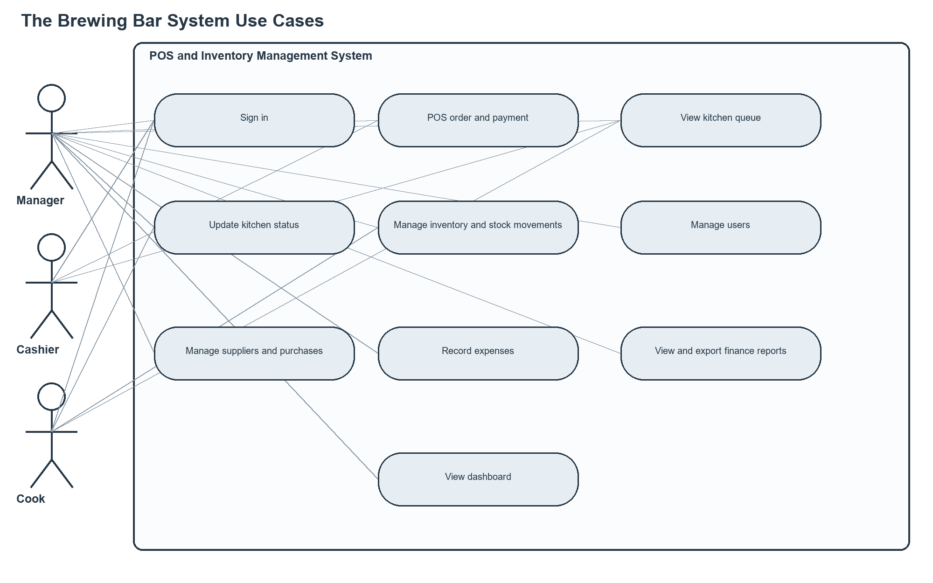

Figure 5. Staff and System Use Diagram

Scopes and Limitations

The Brewing Bar Checkout and Stock System is a website intended for the manager, cashier, and cook. It supports order entry and payment records, kitchen progress, stock records, supplier and purchase records, expenses, staff accounts, and finance reports. The checkout screen estimates item availability using recorded stock changes and a set warning level. Some order-saving and stock-removal steps may not work as intended, as described below. The system does not track ingredients from recipes, create purchase requests automatically, or verify payments through an external payment service.
The system encompasses the following major features and features:
- Sign-in and staff access: Staff sign in using their accounts. Managers can access all areas. Cashiers can enter orders and view kitchen progress. Cooks can update kitchen progress and access stock pages. The website limits access according to each staff member’s role.
- Order entry: Staff can select menu items, quantities, available choices, order type, and notes. The website is intended to calculate totals and the 20% Senior Citizen or PWD discount. Order saving may not work because the saved order requires a date that the saving step does not provide. The website also attempts to save item choices in a list that has not been set up. These issues should be resolved before the order process is considered fully operational.
- Payment recording: Staff can select Cash or GCash. For GCash payments, staff can enter a reference number; however, the website does not verify the payment with GCash or accept an image of payment proof. Staff can also record the amount of cash received and the change given.
- Kitchen progress: Each ordered item appears on the kitchen list. Authorized kitchen staff can update its status from Pending to Preparing to Ready, and then mark the order Completed. Cashiers can view the list but cannot change ticket statuses.
- Stock and purchases: Staff can add stock items and record stock received or removed. The checkout screen estimates stock from these records. The step that removes stock after a sale may not work because it refers to an item that has not been identified. The project does not include a recipe list or automatic ingredient tracking. Managers enter purchases manually. A daily stock-count feature is referenced, but the required setup for storing those counts is missing.
- Stock warnings: The checkout screen labels menu items as available, low, or out of stock using a fixed warning level. It does not check recipe ingredients, create purchase requests, or notify suppliers.
- Finance reports: Managers can filter sales and expense records by date, month, year, and order status. Reports show sales, Cash and GCash totals, discounts, expenses, and net revenue. Reports can be downloaded as PDF or Excel files. The project does not provide downloadable stock reports or sales forecasts.

Limitations
The current release has the following boundaries and implementation gaps:
- Workshop enrollment, training schedules, venue reservations, delivery-app orders, and customer loyalty programs are outside the application.
- Customers and suppliers do not have application accounts. The documented user roles are manager, cashier, and cook.
- The system does not automatically connect to payment providers, supplier systems, or delivery services. Staff enter GCash reference numbers themselves.
- The website saves order and payment details, including a GCash reference number. It does not have customer profiles or a direct connection to payment services.
- The system is designed for the single The Brewing Bar location described in the interview. Multi-branch inventory and consolidated reporting are not implemented.
- The project does not include integrations for cash drawers, barcode scanners, or receipt printers. Staff use a browser on a supported computer or tablet.
- Staff need an internet or local network connection to access the computer that runs the website and stores its information. Offline order entry and later synchronization are not supported. The supplied materials do not describe the café’s network setup.
- Possible future improvements include recipe-based ingredient tracking, adjustable stock warning levels, automatic purchase requests, payment-proof attachments, downloadable stock reports, and support for multiple café locations.
- The supplied materials contain no evidence of installation or completed user feedback. Features described in planning documents but absent from the project are not reported as completed.

Security Plan

Description and limitations
Staff sign-in | Staff need an account to enter the website.
Different staff access | Pages are limited according to manager, cashier, or cook role.
Password protection | Passwords are stored in a protected form. The project does not describe extra strength rules.
Backups and change history | Automatic backups and a complete change history are not included.

Table 3. Security Measures

1. Authentication and Different Access Rights for Each Staff Role
- Passwords are stored in a protected form that cannot be read directly. The project documentation does not specify additional password-strength requirements. Login details should remain private during website setup.

- The website limits access according to each staff member’s role. Managers, cashiers, and cooks have different access, as described below.
  - Cashiers can take orders and view the kitchen list. They cannot open manager pages for finance reports, staff accounts, purchases, or suppliers.

  - Cooks can view and update kitchen tickets and use stock pages. They cannot open manager pages for finance, purchases, suppliers, or staff accounts.

  - Managers can open the dashboard, finance reports, staff accounts, purchases, suppliers, checkout, kitchen, and stock pages. The supplied materials do not show a special process for changing prices or cancelling orders.

- When staff sign out, the website ends their signed-in session. The project does not describe an automatic sign-out warning or screen lock.

2. Safe Forms and Accurate Records
- The website uses built-in safeguards when storing information. It also checks submitted details, such as item names and payment references, before saving them.

- Website forms include protection against unauthorized requests. The current project does not include pages for managing recipes.

- The website checks order, stock, purchase, and account details before saving them. It does not include a feature for uploading payment-proof images.

- The website is intended to save an order and its related details together. Because the required order date and item-choice setup are missing, this process has not been confirmed as working from start to finish.

3. Change Records and Backups
- The project does not maintain a complete history showing who changed each record and what the record contained before and after the change. Basic names and dates on records do not provide a complete change history.

- The supplied project does not include automatic backups or a copy stored in a separate location. A backup plan should be established and documented before the website is used for daily business.

Implementation Plan

The Implementation Plan outlines the structured phases, timelines, deliverables, and operational change management necessary to deploy the system at The Brewing Bar within the term schedule (August 24 – October 9, 2026).

Figure 6: Gantt Chart
Initial Interview and Project Requirements

Introduction
The Brewing Bar is a food, drink, and hospitality training business at Gravahan, New Matina, 74-A Purok 2 Road, Davao City. It serves dine-in and takeout customers and offers barista and bread-and-pastry workshops. The manager described delays in checkout, difficulties keeping track of ingredients and supplies, and the need for clearer daily records. The project team used this background to plan a checkout and stock website. Workshop bookings are outside the website’s current scope.

This interview guide reviews six areas of daily work: speed, information, cost, control, effort, and customer service. The questions are intended to identify business problems, staff needs, and possible improvements:
Table 3. Business review questions
Letter | Focus
P — Performance | Throughput and response time of checkout, order preparation, and reporting.
I — Information | Accuracy, availability, and tracking of ingredient stocks, sales data, and student/event bookings.
E — Economics | Cost control, waste/spoilage monitoring of perishable ingredients, and payment reconciliation.
C — Control & Security | Role-based web permissions, cash accountability, ingredient shrinkage prevention, and enrollment/reservation record integrity.
E — Efficiency | Elimination of repetitive manual tasks, paper ticketing, and scheduling overlaps.
S — Service | Speed, order accuracy, customer satisfaction, and smooth registration for trainees and event clients.

Determine the People to Interview
The people listed below were selected because their responsibilities cover the main sales and record-keeping tasks:

Table 4. Determine the People to Interview
Interviewee | Why They Are Included | Justification / Role Coverage
General Manager | Primary Informant (Confirmed) | Provides high-level operational workflows, revenue reporting, supplier management, training schedule policies, and business pain points.
Store Supervisor / Head Barista | Secondary (Subject to Manager Referral) | Manages ingredient prep, daily received stock records/outs, waste tracking, and kitchen/bar coordination during rush hours.
Cashier / Counter Front-Liner | Secondary (Subject to Availability) | Operates order-taking, receives cash and digital payments (GCash), and handles direct customer inquiries.
Customer / Trainee Patron | Secondary (Optional Survey/Quick Interview) | Provides the end-user perspective on ordering speed, menu clarity, and the workshop registration experience.

Interview plan: The first interview will be conducted with the General Manager. The manager will determine whether brief follow-up conversations or observations with staff and customers are permitted and necessary.

Interview Objectives
General objective
The interview aims to learn how The Brewing Bar handles daily work, where delays or difficulties happen, and what the manager needs from a checkout and stock website.

Specific objectives
- Record how staff take orders, give receipts, and handle payment for dine-in and takeout sales.
- Learn how staff count, record, and restock food, drinks, baking supplies, and ingredients that can spoil.
- Find out how long sales take during busy hours, weekends, and training or event days.
- Ask about losses from spoiled or expired ingredients, kitchen waste, and items used but not recorded.
- Learn how staff check cash at the end of a shift and keep track of Cash, GCash, and bank transfers.
- Find out which daily records, shift handovers, and stock counts take the most effort.
- List desired checkout and stock features, such as counting ingredients from recipes, low-stock warnings, receipt printing, and daily sales reports.

Preparing the Interview Questions
The questions cover daily work, checkout and stock tasks, and the needs for setting up and using the website.

Table 5. General Background Questions (Baseline Setup)
No. | Question
1 | When was The Brewing Bar established, and what is your overall vision for the business and training operations?
2 | How many staff members currently operate the counter, cash register, and bar/kitchen areas?
3 | What is your average daily transaction count on normal weekdays versus peak weekends or event days?
4 | What tools or methods (e.g., cash register, paper order pads, logbooks, Excel spreadsheets) are currently used to punch orders and track inventory?
5 | What recurring problems, checkout delays, or stock discrepancies occur most frequently during operations?
6 | Which daily counter and inventory tasks consume the most time and would benefit most from an automated checkout system and inventory system?
7 | What internet connection is active at the store (e.g., fiber, mobile Wi-Fi), and what devices (PC, laptop, tablet, phone) are available at the counter or office?

Table 6. Questions about checkout and stock work
PIECES Area | Interview Questions
P  Performance | On average, how long does it take a cashier to ring up an order, accept payment, and issue a receipt?  Do long queues form at the counter during rush hours due to manual order writing or slow payment verification?  How long does it take management at the end of the day or week to calculate total sales and assess current stock on hand?
I  Information | How accurate is your current visibility into on-hand quantities of perishable ingredients (e.g., milk, coffee beans, syrups, baking goods)?  How do staff know when an item is sold out or when an ingredient hits its reorder threshold?  What daily or monthly sales reports do you need to make purchasing decisions, and are they currently easy to generate?  What specific sales reports (e.g., daily gross sales, top-selling items, payment channel summaries) do you need for daily business decisions?
E  Economics | What estimated losses occur each month from spoiled dairy, expired stock, kitchen waste, or incorrect order preparation?  Have you experienced end-of-day cash shortages, unrecorded sales, or discrepancies between physical cash and sales records?  Where do you see the greatest opportunity to cut costs by automating stock monitoring and order calculation?
C  Control & Security | How do you verify proof of payment for digital transactions (such as GCash or bank transfers) before releasing an order?  What controls or access limits prevent unauthorized price overrides, voided sales, discounts, or employee theft?  How are physical stock counts audited and reconciled against recorded purchases and sales?
E  Efficiency | How much staff time is spent manually writing paper receipts, tallying physical stock, or calculating daily register totals?  Are ingredient restock orders delayed due to a lack of immediate, centralized inventory data?  Are orders ever miscommunicated between the front counter cashier and the barista/kitchen staff?
S  Service | What customer complaints occur most often regarding checkout speed, pricing confusion, or receipt accuracy?  How does an unexpected stockout of a popular drink or pastry impact customer satisfaction?  How would a fast, automated checkout system checkout improve the overall dining experience for your customer?

Table 7. Questions about desired website features
No. | Question
1. Recipe-Based Inventory Deduction | Should the checkout system automatically deduct specific raw ingredients (e.g., 18g espresso beans, 220ml milk, 30ml syrup) from total inventory every time a drink or pastry is sold?
2. Low-Stock Alerts & Reorder Points | Do you need automated dashboard warnings or notifications when critical raw supplies reach minimum stock levels?
3. Hardware Compatibility | What hardware will be used at the checkout counter (e.g., desktop PC, tablet/iPad, touchscreen checkout system terminal, barcode scanner, cash drawer, receipt printer that prints on heat-sensitive paper)?
4. Kitchen/Bar Order Dispatch | Should the system route punched orders directly to a kitchen/bar printer or a Kitchen Display System (kitchen screen) screen to streamline barista workflow?
5. Payment Method Integration | How should the checkout system record split payments, service charges, discounts (e.g., Senior Citizen/PWD), and non-cash methods like GCash and Maya?
6. User Roles & Access Permissions | What distinct permission levels should exist in the system (e.g., Manager access for inventory/reports vs. Cashier access strictly for ringing up sales and opening the cash drawer)?
7. Exportable Data | Do you require the system to export daily, monthly, and annual sales and stock audit reports into downloadable PDF or Excel/CSV formats?

Company Interview and Data-Gathering Questionnaire
For preliminary interviews about the business and its needs

Company/Business Name: The Brewing Bar____________________________________________
Date: September 5, 2026___________________________________________________________
Respondent: General Manager_______________________________________________________ Position : General Manager_________________________________________________________

Questionnaire for a One-Term Project
I. Priorities for the First Version
- Which matters most on the first day: taking customer payments at the counter or keeping track of ingredients and other stock?
- Inventory
- Can workshop sign-ups and venue bookings continue through social media or direct messages while this project focuses on café checkout and stock?
- Yes
- How many menu items do you offer, and can the first version focus on your main drinks and pastries?
- 100 items, yes, especially the inventory.
II. Ingredients and Recipes
- Would you like stock counted as whole items, such as cookies, bottled drinks, cups, milk cartons, and coffee bags, or measured by recipe amounts, such as grams of coffee and milliliters of milk per drink?
- Both
- Do you already have a final recipe list with exact amounts, or would counting whole items and containers be easier for this school project?
- Yes
III. Payment Methods
- Do customers pay only with Cash and GCash, or do they also use bank cards and Maya?
- Strictly Cash and GCash
- For GCash, is entering the four-digit reference number enough, or should staff also attach a screenshot of the payment?
- 4-digit reference number sufficient to verify payment and optional uploaded screenshots.

IV. Devices and Workplace
- Which device will staff use at the counter: a laptop, desktop computer, or tablet?
- Laptop or Tablet
- Is there a working receipt printer at the café, or are screen receipts enough for the school demonstration and trial?
- No working receipt printer on-site.
V. Staff Orientation and Trial
- Could you join a short website demonstration and try it in late September or early October?
- Yes. Around 10 am to 10 pm weekdays, Weekends 6 - 8 pm.
- Which staff members will try the website and compare it with the current paper process?
- Manager/Counter and the Cook.

Appendix A — Interview Consent & Confidentiality Note
Read or provide this statement to each interviewee before starting:
Thank you for speaking with me. This interview is part of a school project to understand how the business works and where improvements may help. Your answers will be kept private and summarized for this project. You may skip any question or stop at any time. Do you agree to take part, and may I take notes?

Appendix B — Interview Documentation Template
Date / Time | September 5, 2026 at PM
Branch / Location | The Brewing Bar
Interviewer | Enola, Yute, Zaragosa
Interviewee Name & Role | Manager
Consent Obtained (Y/N) | Yes

PIECES Area | Notes / Responses | Follow-up Needed?
General Background | Establish on Feb 10, 2023  Mission  To continually improve business operations and customer care while providing high-quality, affordable food, beverages for customers, especially for students.  Vision  To be a cozy and affordable place to hang-out customers, especially for students.  1 Manager (Counter/Casher)  1 Bar/Kitchen  60 - 70+ for normal days  more than 100+ for peak hours and weekends  Notebook (handwritten)  Transition from casher to kitchen  Hard to track the Inventory  Inventory from start to finish of the business operation.  And overall correctness and efficiency of the Inventory tracking  Devices  Laptop and tablet  Internet Connection  Converge
P — Performance | No OR, Take a photo of the receipt and conformations and check the date.  Yes on rash hours and Nope and the payment was fast verification.  Every end of the day (1-2 hours depending how busy the day is).
I — Information | 90% accurate  Add and sub of inventory 90% accurate  Daily or weekly most ordered by the customer (mostly this week) and currently trending that customer might want to order.
E — Economics | Less than 600 pesos  None, but in inventory yes. When we haven’t included what the family member eats or gets that day.  Time and efficiency
C — Control & Security | Photo of the receipt and the transaction verification number.  The manager is always at the counter/cashier or the business owner and family members.  Manually record it using a notebook. Every end of the day the inventory was checked by the manager and the cook if the ingredients still have stock or they use so much stock for today.
E — Efficiency | 20 to 30 mins calculating daily register/sales totals.  In the store inventory, No. But from the suppliers, Yes.  Yes and the order order will be delayed for 2-3 mins
S — Service | So far no complaints yet.  The order will be changed but they still inform the customer what foods or drinks they want as alternative food or drinks.  Very efficient for both the customers and the business.

Website Screen Examples

Login page

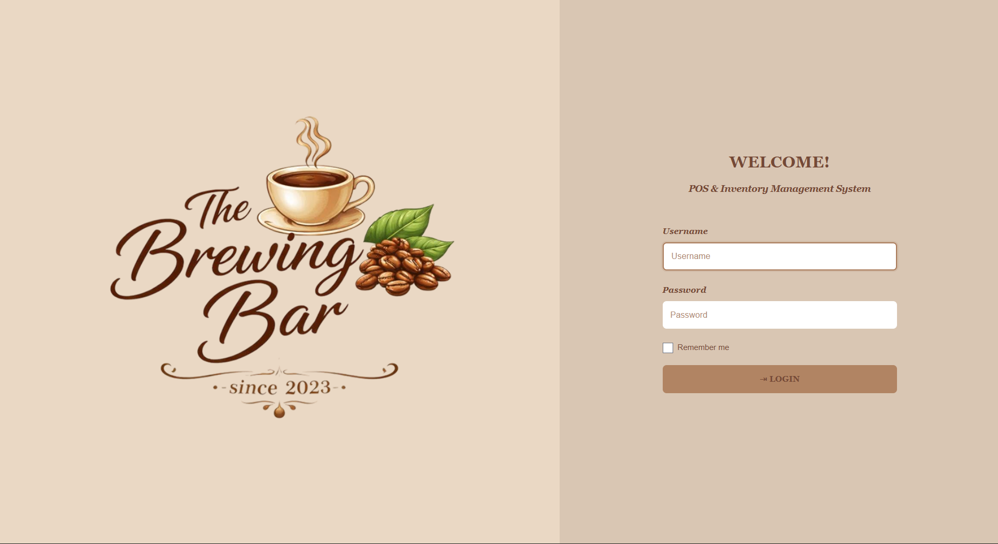

Dashboard page

Point of sale page
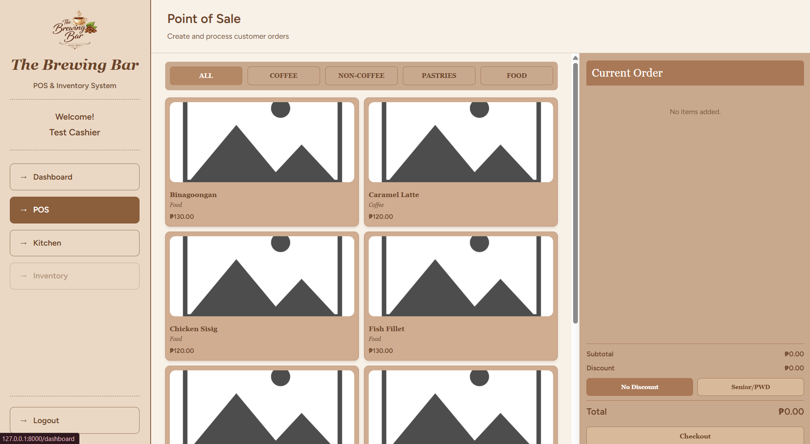

Kitchen page
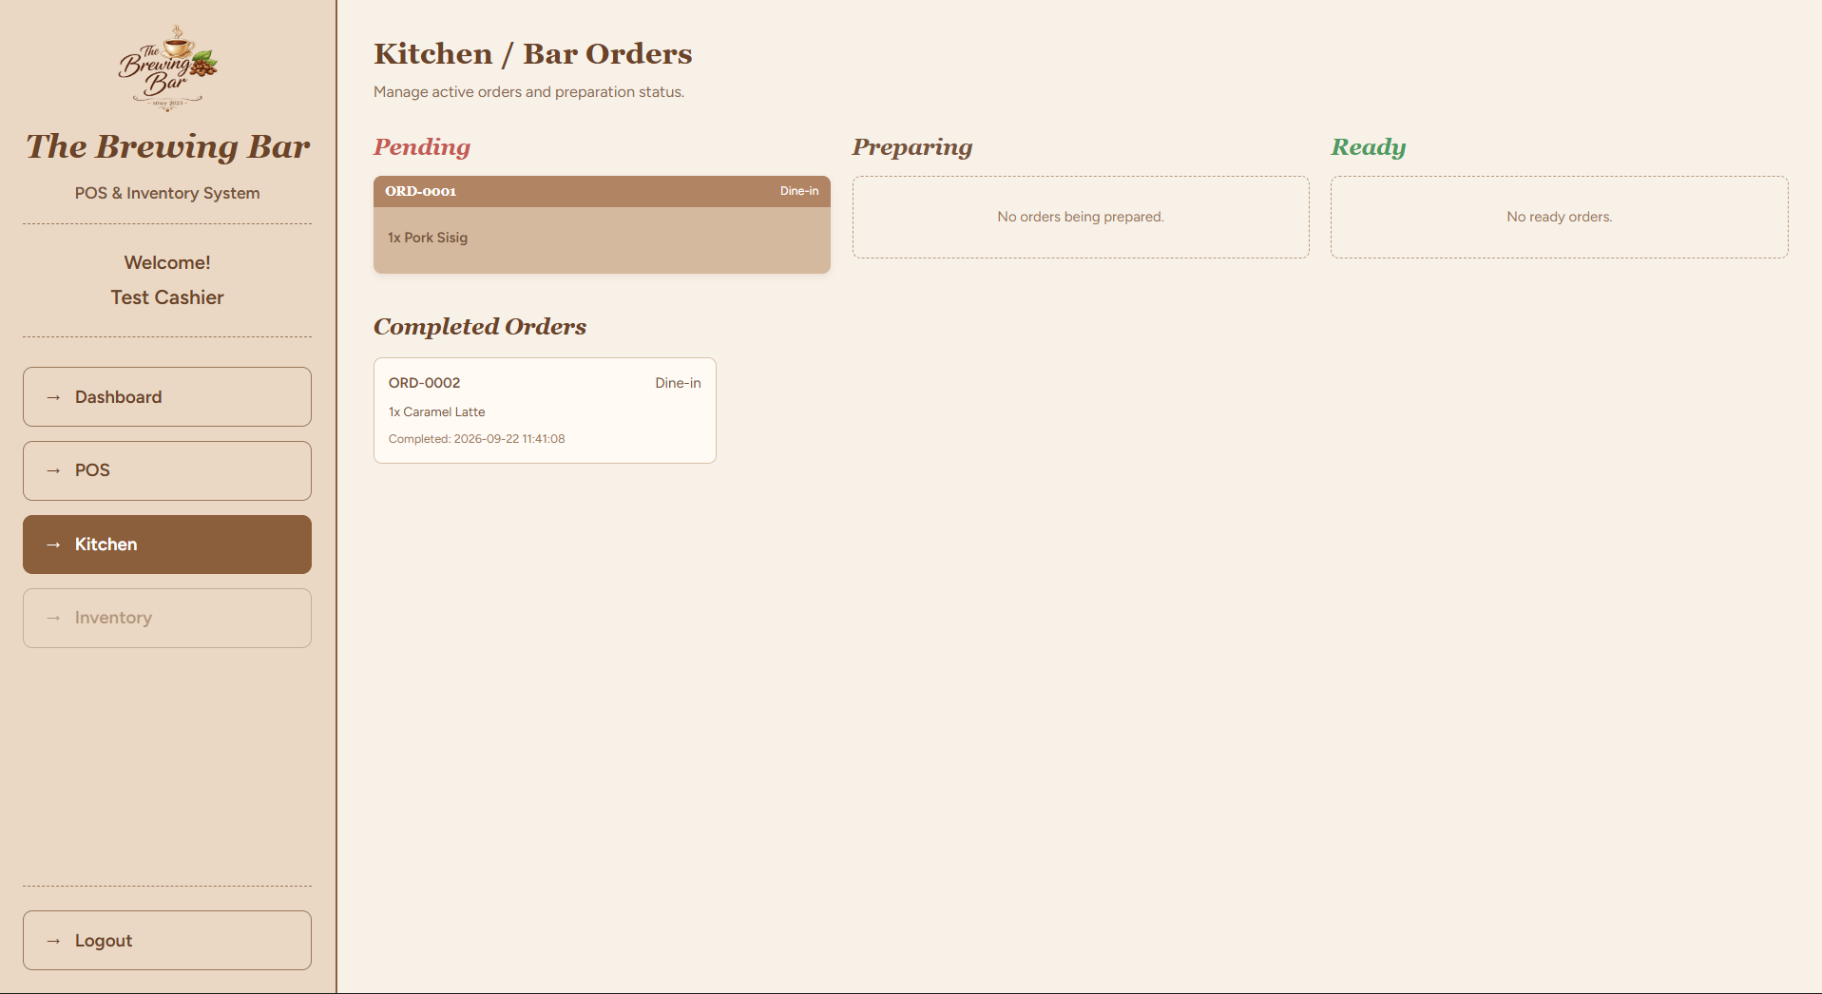
The contents pages in the original template use typed page numbers. Update the contents and the figure and table lists in Word after the final page layout is set.

How the Website Stores Information
Figure 4 shows how the project organizes stored information. It reflects the setup found in the supplied project. The earlier diagram included recipe and stock-history lists that are not present. The project records stock received and removed separately. It also attempts to save menu-item choices in a separate list, but the setup for that list is missing. Exact names in parentheses in the reference table match labels used in the project files.
Record type (name used in project files) | Information saved (field names in parentheses) | How the records connect
Staff roles (roles) | Unique role number (id); role name (name); description | One role can be assigned to several staff accounts.
Staff accounts (users) | Unique account number (id); staff role number (role_id); name; email; protected password; verification and account dates | Each account has one role. Staff accounts are linked to orders, payments, stock records, and kitchen work.
Menu categories (categories) | Unique category number (id); name; description; active or inactive | One category can contain several menu or stock items.
Units (units) | Unique unit number (id); unit name; short form | A unit can be used by several items, such as grams or pieces.
Storage locations (inventory_locations) | Unique location number (id); name; description; active or inactive | One location can contain several items.
Menu and stock items (inventory_items) | Unique item number (id); category number (category_id); location number (inventory_location_id); unit number (unit_id); name; item type; price; description; active or inactive | An item can appear on order lines, received-stock records, removed-stock records, and purchase records.
Choice groups (option_groups) | Unique group number (id); name; description | A group contains choices and can be assigned to menu items.
Menu choices (option_values) | Unique choice number (id); group number (option_group_id); name; added price; active or inactive | Each choice belongs to one choice group.
Item choice links (inventory_item_option_groups) | Unique link number (id); item number (inventory_item_id); group number (option_group_id); required or optional | Connects a menu item with the choices available for it.
Suppliers (suppliers) | Unique supplier number (id); supplier name; contact person; phone; email; address; active or inactive | A supplier can be linked to received stock and purchase records.
Received stock (stock_ins) | Unique record number (id); item number (inventory_item_id); amount received; supplier number (supplier_id); staff account number (recorded_by); date; notes | Shows items added to stock and who recorded them.
Removed stock (stock_outs) | Unique record number (id); item number (inventory_item_id); amount removed; staff account number (recorded_by); reason; date; notes | Shows items removed from stock and who recorded them.
Customer orders (orders) | Unique order number (id); cashier account number (cashier_id); order number; queue date and number; order type; progress; subtotal; discount; total; order and completion dates | One order can contain several order lines and one payment record.
Order lines (order_items) | Unique line number (id); order number (order_id); menu item number (inventory_item_id); quantity; unit price; line total; notes | Each line belongs to one order and one menu item.
Kitchen tickets (kitchen_order_items) | Unique ticket number (id); order-line number (order_item_id); cook account number (prepared_by); progress; start and completion times | Each ticket belongs to one order line.
Payments (payments) | Unique payment number (id); order number (order_id); staff account number (received_by); payment method; amount; cash received; change; reference number; date paid | Each payment record belongs to one order.
Purchases (purchases) | Unique purchase number (id); supplier number (supplier_id); date; reference number; notes | One purchase can include several purchased items and may be linked to expenses.
Purchased items (purchase_items) | Unique record number (id); purchase number (purchase_id); received-stock number (stock_in_id); item number (inventory_item_id); quantity; unit cost; total cost | Links each purchased item to its purchase, item, and received-stock record.
Expenses (expenses) | Unique expense number (id); related purchase number (purchase_id); description; category; amount; date; notes | An expense can be linked to a purchase or recorded on its own.
The diagram shows how the records are connected. Each staff role may be assigned to multiple staff accounts. A menu category may contain multiple stock items, and an item may appear in multiple stock records and order lines. An order may contain several items and has a payment record. A supplier may be linked to multiple purchases. The reference list below provides the exact names used for these records.

Staff Roles and Access
The website is intended for three staff roles: manager, cashier, and cook. The manager can use the dashboard, checkout, kitchen, stock, staff accounts, supplier and purchase records, and finance reports. The cashier can take orders and view the kitchen list. The cook can view and update kitchen tickets and use stock pages. Customers and suppliers do not sign in; staff enter their information when needed.

Website Setup Plan
The project’s setup guide describes how to run the website on a computer. The process requires installing the website tools and a database program, entering private connection details, preparing the stored-information structure, and starting the website. Assistance from a person experienced in website installation may be required. The project files show that the website materials are available; they do not confirm installation at The Brewing Bar or handover to the client.
The supplied materials do not include a signed handover, a working café website address, installation photographs, staff-training records, or feedback from a demonstration. Add supporting evidence to the appendices before reporting installation or training as complete.

Staff Evaluation
The evaluation form does not yet contain staff ratings or responses. The manager, cashier, and cook should use the website before completing the form. Leave the rating fields blank until responses are collected. The 10-question System Usability Scale provides a standard way to summarize how easy a system is to use. Do not report a score or claim staff approval before collecting responses.

10-Question Ease-of-Use Questionnaire
No. | Statement | Rating (1–5)
1 | I think that I would like to use this system frequently.
2 | I found the system unnecessarily complex.
3 | I thought the system was easy to use.
4 | I think that I would need the support of a technical person to be able to use this system.
5 | I found the various functions in this system were well integrated.
6 | I thought there was too much inconsistency in this system.
7 | I would imagine that most people would learn to use this system very quickly.
8 | I found the system very cumbersome to use.
9 | I felt very confident using the system.
10 | I needed to learn a lot of things before I could get going with this system.
Rate each statement from 1 (strongly disagree) to 5 (strongly agree). For questions 1, 3, 5, 7, and 9, subtract 1 from the rating. For questions 2, 4, 6, 8, and 10, subtract the rating from 5. Add the adjusted ratings and multiply the total by 2.5. The final score ranges from 0 to 100 and is not a percentage. Calculate it only after completed forms have been collected (Brooke, 1996).

Questionnaire on Website Features
Feature | Question for staff | Rating
Taking orders | Can you choose items, quantities, and order type easily? | 1 2 3 4 5
Payments | Can you record Cash or GCash clearly? | 1 2 3 4 5
Kitchen progress | Can kitchen staff update order progress? | 1 2 3 4 5
Stock | Can you record stock received or removed? | 1 2 3 4 5
Reports | Can the manager find the sales and expense information needed? | 1 2 3 4 5
Staff access | Can each staff member find the pages needed for their role? | 1 2 3 4 5
Comments | What should be improved?

Questionnaire on Website Quality
Quality area | Question for staff | Rating
Ease of use | Was the website easy to learn? | 1 2 3 4 5
Speed | Did the pages respond quickly enough? | 1 2 3 4 5
Reliability | Did the steps work as expected? | 1 2 3 4 5
Clarity | Were the words and messages easy to understand? | 1 2 3 4 5
Access | Could you use the pages needed for your role? | 1 2 3 4 5
Comments | What should be improved?
Feedback and observation notes: ______________________________________________________________________________
________________________________________________________________________________________________________
Evaluator role: __________________ Date: __________________ Device/browser: __________________

Findings and Discussion
A review of the project files found pages for staff access, orders, payments, kitchen progress, stock received and removed, suppliers, purchases, expenses, and manager finance reports. Their presence in the project files does not confirm that every step works correctly. Three order issues remain: the required order date is not supplied when an order is saved, item choices are sent to a list that has not been set up, and the stock-removal step may fail because it refers to an unidentified item. One link between order items and stock items also uses mismatched names, which may prevent the website from matching those records. These issues should be addressed and reviewed before the full process is reported as successfully evaluated.
Some features described in the earlier draft are not present in the project. There are no saved recipes or ingredient amounts, so the system cannot calculate how much milk, coffee, or syrup each sale uses. The checkout screen uses a fixed stock warning level. Managers enter purchases manually; the system does not create purchase requests automatically. The project also lacks a complete change history and automatic backup plan. These are current limitations and possible future improvements.
Before submission, add the actual staff responses, summarize the findings, record any identified problems and resulting changes, and include evidence of a demonstration or installation. No numerical results are reported because none were provided.

Team Reflections
The project guide asks each team member to describe their own work and experience. The supplied materials do not explain each person’s contribution, so the named team members should complete their own reflections.

Enola, Dionne Emmanuel M.
Write one paragraph in your own words about what you did, what you learned, a challenge you faced and how you handled it, what you learned from the team or client, and what you would improve next time.

Yute, Christina Paula P.
Write one paragraph in your own words about what you did, what you learned, a challenge you faced and how you handled it, what you learned from the team or client, and what you would improve next time.

Zaragoza, Liz T.
Write one paragraph in your own words about what you did, what you learned, a challenge you faced and how you handled it, what you learned from the team or client, and what you would improve next time.

References
Beck, K., Beedle, M., van Bennekum, A., Cockburn, A., Cunningham, W., Fowler, M., Grenning, J., Highsmith, J., Hunt, A., Jeffries, R., Kern, J., Marick, B., Martin, R. C., Mellor, S., Schwaber, K., Sutherland, J., & Thomas, D. (2001). Manifesto for Agile Software Development. https://agilemanifesto.org/
Brooke, J. (1996). SUS: A “quick and dirty” usability scale. In P. W. Jordan, B. Thomas, B. A. Weerdmeester, & I. L. McClelland (Eds.), Usability evaluation in industry (pp. 189–194). Taylor & Francis.
Laravel. (n.d.). Laravel website development guide. Retrieved October 7, 2026, from https://laravel.com/docs/12.x
The Brewing Bar manager. (2026, September 5). Preliminary interview on business operations and system requirements [Personal communication].

Appendix Completion Checklist
• Appendix A — Signed request and approval letter: not supplied; attach the signed copy.
• Appendix B — Usability questionnaire and collected results: questionnaire included above; completed responses and score summary not supplied.
Appendix C - Staff questions about website features and results: questions are included above; no completed answers were supplied.
Appendix D - Staff questions about website quality and results: questions are included above; no completed answers were supplied.
Appendix E - Project and development evidence: The project files are available. Add a screenshot of the project and evidence of its development. Do not include passwords or private login details.
Appendix F - Installation evidence: no evidence was supplied. Add real setup and installation materials if the website has been installed.
• Appendix G — Data gathering and client consultation records: the September 5, 2026 interview notes are in the source documentation; add any supporting signed consent, photos, or meeting records that exist.
• Appendix H — Demonstration and user feedback: not supplied; attach actual demonstration photos/screenshots and feedback records after the activity.

